Tessa Jowell GP Surgery - Service Guide
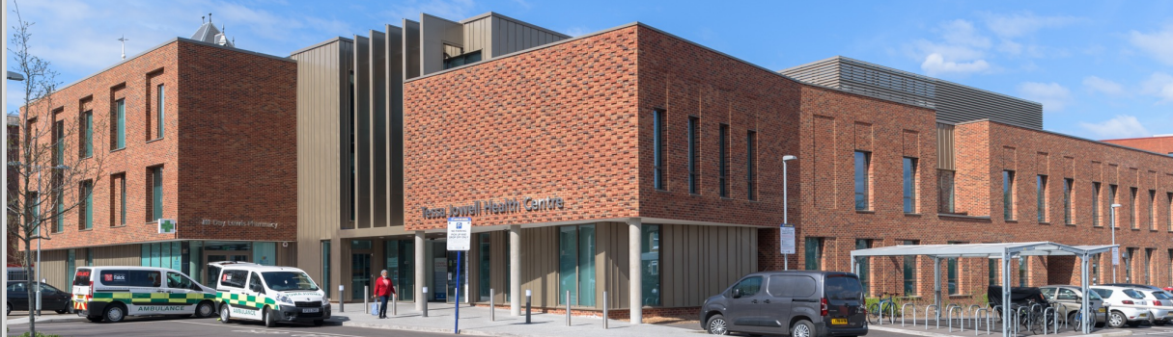

Tessa Jowell GP Surgery - Site Details
Tessa Jowell GP Surgery,

First Floor, Tessa Jowell Health Centre,

72H East Dulwich Grove,

London
SE22 8EY
Tel: 020 8194 7600
Website: www.tessajowellgpsurgery.co.uk

Email: SOUCCG.TJGP@NHS.NET

Welcome to the Tessa Jowell GP Surgery

At the Tessa Jowell GP Surgery, we aim to treat all our patients promptly, courteously and in complete confidence. This leaflet is for both existing patients and those considering registering with us. It tells you about our services, how to access them and some general information about how our Practice operates.

Opening Hours
Monday: 8:00 - 6:30pm
Tuesday: 8:00 - 6:30pm
Wednesday: 8:00 - 6:30pm
Thursday: 8:00 - 6:30pm
Friday: 8:00 - 6:30pm
Saturday 9:00 - 1:00pm (Extended hours – Pre-booked appointment only)

Out of Hours telephone number: 111
When the Practice is closed the Out of Hours Service, provided by SELDOC, is available for urgent problems that cannot wait until the Practice reopens. For emergency situations patients should dial 999
Community GP appointments can be accessed at the Tessa Jowell Health Centre via the extended Primary Care Access Hub. These appointments can be booked by the Tessa Jowell GP Surgery Practice team for acute needs if a suitable appointment is not available at the practice.

Our Team
Our doctors, nurses and allied health professionals, supported by our administrative teams, are committed to providing a professional and friendly service for everybody.
Business Manager Golam Morshed

Practice Manager
Roberta Fletcher

Practice Supervisor
Andrew Riley
Roberta and Andrew have overall day-to-day responsibility for the surgery and ensure that the services are running smoothly.

The Clinical team at The Practice are led by the clinical lead –
Dr. Jessica Parsons

The clinical team is comprised of General Practitioners and Allied Health Professionals:
Dr Jessica Parsons - GP
Dr. May Myanmar - GP
Dr Sebastian Garber – GP
Dr Oyin Koledoye - GP
Dr Tina Shivji - GP

Veronica Thorogood- Advanced Practitioner
Roshan Musubika - Practice Paramedic
Takara Perry - Clinical Pharmacist
Sylvie Keumajou - Clinical Pharmacist

Practice Nurses
Julia Gale, Practice Nurse Diploma Adult Nursing, BSc Adult Nursing
Deborah Akhigbe- Practice Nurse
Taiwo Olajide- Practice Nurse
Jennifer N Onyiah- Practice Nurse
Nicola Button -Practice Nurse

Healthcare Assistants
Reaz Ahmed

Administrative Team
The team is your main point of contact when you use our services and are always there to help. They may need to ask you medical details in order to assist you and help direct you to the most appropriate clinician and at all times are working under the instructions of the doctors. All information given to them is treated in confidence. The more information you are able to give to the team the better they will be able to assist you.

Patient Service Navigators
Lisa McManus . Patricia Roberts . Charlene Thomas . Adriana . Quintero-Villaneda . Leemara Smith . Carmen Almeida . Jennie Thomas . Adrian Mihal . Lesley Konuah . Robert Kelly . Aimee Kelley

Complaints Department Cigdem Korkmaz

How to Register
You can register with us today and we will contact you to arrange a full health check and introduce you to our Practice.
For a detailed map of our catchment area please visit www.tessajowellgpsurgery.co.uk

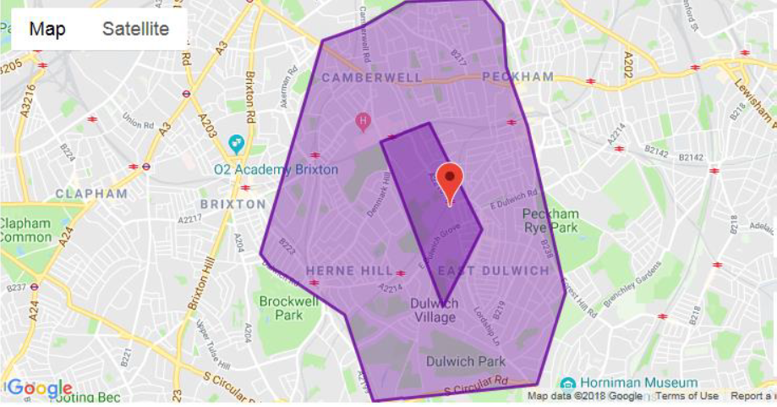

Registering is Easy

Just click the link below and follow instructions for online registration.

New Patient Registration – Tessa Jowell GP Surgery

Once registered we will arrange for you to have a brief health check with a Practice Nurse or Health Care Assistant at a time convenient to you. This will give you an opportunity to discuss any health concerns and enables us to learn more about your health needs.

Appointment Booking
To book an appointment, order prescriptions, and to view what we have available of your entire medical record please download our Evergreen life / AskMyGP app and create an online account using the link below, alternatively you can call us on 0208 194 7600 between 08.00 – 18.30 Monday- Friday.

PLEASE NOTE: there are only a limited amount of daily GP appointment slots from 8am online and on the telephone, when this capacity is met the online appointment system is then disabled until the next working day, we will still accepts calls for general enquiries and urgent cases which will be prioritise and triaged as normal.

Please read the Important notice before downloading the Evergreen app

Before installing the Evergreen Life App it is important that you obtain your ODS code, Linkage Key and ID account number from your GP Practice before hand, this information will be required to complete the downloading process, please email the surgery at: souccg.tjgp@nhs.net or call 0208 194 7600 08.00 – 18.30 Monday- Friday. Once you have obtained your unique information you can then begin the downloading process, (do not download any other app other than the Evergreen Life App), on completion of the installation you can then go online and start taking control of your health needs, remember the Evergreen Life / AskMyGP App will NOT work properly without your ODS code, Linkage Key and ID account number which is the key to linking your medical details to the app.

When booking appointments the app will direct you to the Ask My GP Tag which is how appointments are booked.

Click the link or scan the QR code below to get the app now.
https://link.evergreen-life.co.uk/QsDm1wZzWsb

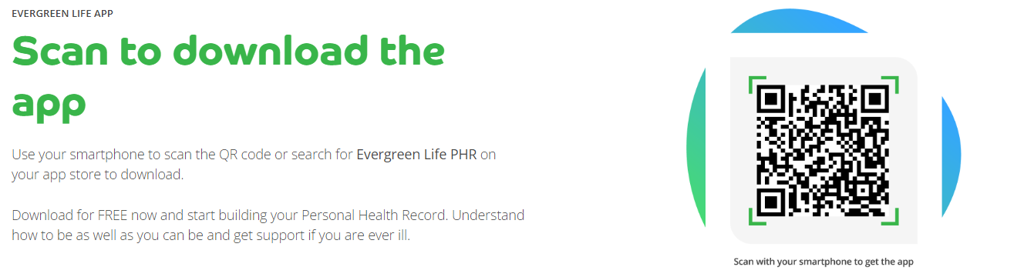

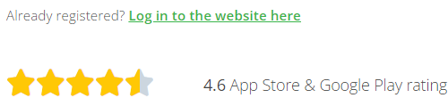

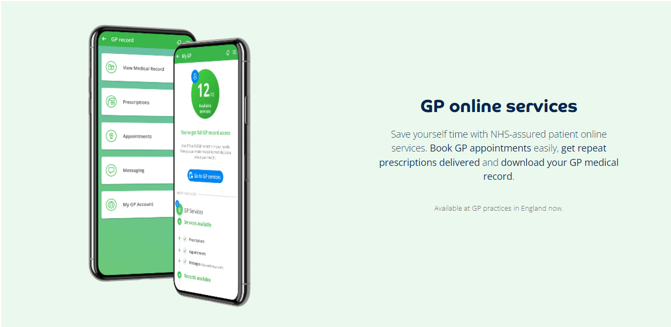
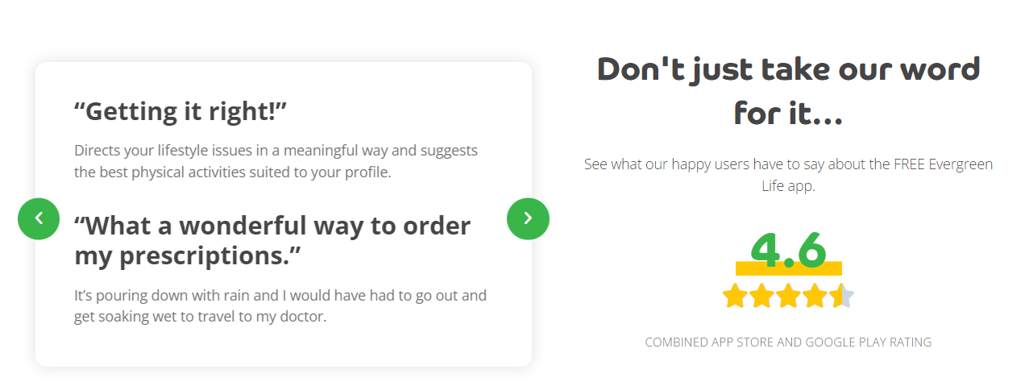
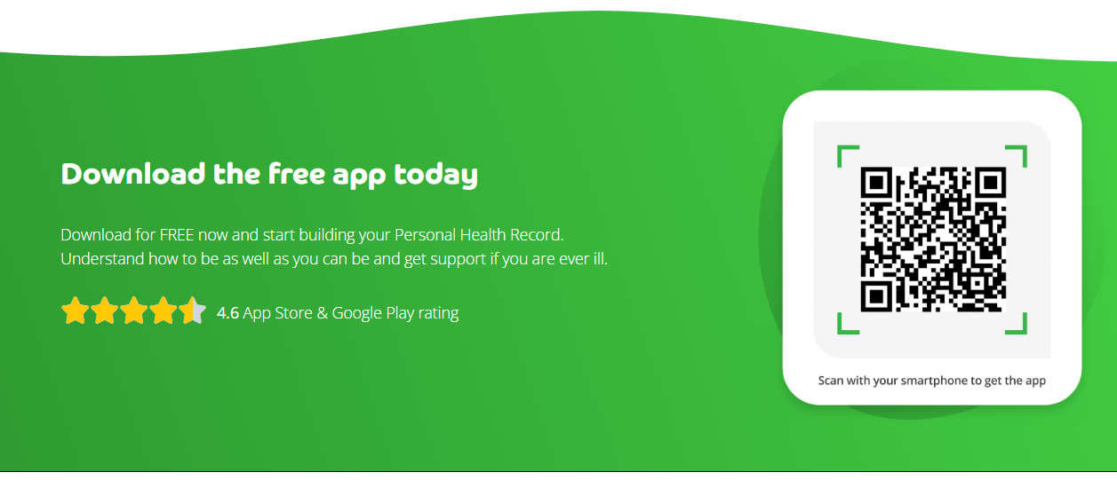

If you are experiencing any other technical issues with the evergreen / askmyGP app you can contact
The evergreen helpdesk on 0161 768 6063 Monday to Friday 09.30 am to 5pm.

Email: Hello@Evergreen-Life.co.uk or Visit: https://help.evergreen-Life,co.uk

Telephone Consultations
We can assist with many request over the telephone without face-to-face contact with a doctor. Advice can be given and prescriptions issued. If you would like to speak to a doctor regarding a non-urgent issue, please request a telephone consultation.

Home Visits
To request a home visit please call us on 020 8194 7600 a clinician will call you before coming out to you to assess the request if possible and within our catchment area.

Cancelling Appointments
Please ensure that you cancel any appointment that you no longer require at least one hour before the appointment time this will enable us to offer this to another patient. Call us on: 020 8194 7600.

Please remember if you do not attend your appointment and have not notified us that you are not attending you are preventing another patient from using that appointment. Patients who repeatedly fail to attend appointments may be asked to register with another practice.

Disabled Access
At the Tessa Jowell GP Surgery, we are based on the first floor. There are lift facilities and hearing induction loops at this site.

Repeat Prescriptions
Please use your online access to order your repeat medications.
The Electronic Prescribing System ensures your prescription goes electronically to your nominated pharmacy please inform the reception team which pharmacy you would like to nominate. Alternatively you can nominate via the pharmacy.

Please ensure you allow two full working days for us to prepare your prescription. In some cases and following NHS guidelines you may be required to attend a medication review before your repeat can be issued.
To avoid any errors we do not take any repeat prescription requests via the telephone.

Repeat Dispensing Scheme
If you are on regular medication your doctor can issue several prescriptions in advance to be held and distributed when you need them by your chosen pharmacy. This saves the patient time and inconvenience when ordering and collecting prescriptions.

Statements of Fitness for Work
Sickness Certificates for periods of less than 7 days should be signed by the patient themselves, in the form of a self-certification Form (SC2), available from your employer, GP or online at

Click here for SC2 form

We will issue (sick certificate) to registered patients for whom we provide clinical care. A statement will not be issued to a patient until they have been off work for more than 7 calendar days. DSS certificates of incapacity are free and GP discretion see Non NHS Services.

Travel Medicine
We provide an advice and immunisation service to meet your travel needs. Please check your requirements with us as soon as you make your travel plans as some medicines require several courses. Please complete our online travel form then contact the surgery and book an appointment with our practice nurse. Travel advice is also available from www.fitfortravel.nhs.uk. Please note that not all travel vaccinations are available free on the NHS, there may be a charge for any immunisations you require to travel.

Test Results
Please note that the receptionist can only give results to patients once the Doctor has checked the results and given authorisation. In order to maintain patient confidentiality, results can only be given to the patient themselves.
Parents of patients under 18 can request results on the child’s behalf.
Most blood, urine and swab tests take up to two weeks to be processed and completed by the laboratory, these are then sent back to the surgery for review by your clinicians.
Patients are kindly asked to contact the surgery, after 2pm, two weeks after taking the test. The administrator will read back to you any comments that the clinicians have made and assist you with any follow up appointments, if required. If you have previously arranged a follow up appointment with your clinician you do not need to ring for the results.

Specialist and Hospital care (Referrals)
If a GP or another member of our healthcare team believes you need hospital treatment or specialist care elsewhere, this will be organised on your behalf.

Non NHS Services & Private Fees
Certain services provided by your doctor are not covered by the NHS and you may be asked to pay a fee. These include:
- A Pre-employment Medical
- A Private Medical
- An Insurance Claim
- A Fitness To Drive Medical
- Travel immunisations
- Certain occupational vaccinations

Please call 0208 8194 7600 for more information or speak to a member of our administration team.

Medical Records & Confidentiality
All patient records are confidential. All our staff are trained in accordance with the Data Protection Act and work under strict rules of confidentiality.

Freedom of Information Act (2000)
From 1 January 2005, you can ask any public authority for information they hold. Public authorities will provide you with the information unless there is a good reason for not doing so.

How We Use Your Records
The people who care for you use your records to:
- Provide a good basis for all health decisions made by you and care professionals
- Allow you to work with those providing care
- Make sure your care is safe and effective, and
- Work effectively with others providing you with care
Others may also need to use records about you to:
- check the quality of care (such as clinical audit)
- protect the health of the general public
- keep track of NHS spending
- manage the health service
- help investigate any concerns or complaints you or your family have about your health care
- teach health workers and
- help with research
Some information will be held centrally to be used for statistical purposes. In these instances we take strict measures to ensure that individual patients cannot be identified. We use anonymous information, wherever possible, but on occasions we may use personally identifiable information for essential NHS purposes such as research and auditing. However, this information will only be used with your consent, unless the law requires us to pass on the information. More information about how your information is used can be found on the practice website under the link to privacy notices.

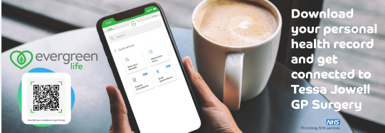

Changes to Personal Details
Please notify the surgery in person or by email of any changes in your personal details such as your name, address or telephone number. This will enable us to keep our records up to date. This is very important as we may need to contact you at short notice.

Patient Rights and Responsibilities
You have a right to expect a high standard of medical care from our practice and we will try at all times to provide the very best care possible within the resources available.
In order to assist us in this, we require that you take full responsibility for ensuring that you do not abuse the service. It is your responsibility to ensure that you keep appointments, on time, and follow the medical advice given. Please restrict your appointment to a maximum of one medical issue per appointment. If you have more issues you will need additional appointments.
The Tessa Jowell GP Surgery operates a zero tolerance policy. We will not tolerate any violent behaviour or abuse towards any member of our team. Any such behaviour will result in removal from our list.

Patient Participation Group
This group is run by a committee of patients for the benefit of the Practice and Patients. This is your group so please ask how you can contribute your ideas. Further information can be found on the practice website at: www.tessajowellgpsurgery.co.uk

Complaints
Should you wish to make a complaint about our service, in the first instance please ask to speak to the complaints department,
If the Practice cannot resolve the issue or should you be dissatisfied with the outcome you can put your complaint in writing or send an email to the Practice Manager.

When all options has been reached then, you also have the right to approach the following:

Independent Complaints Advocacy Service: 0300 456 2370
Web: www.pohwer.net

The Parliamentary Ombudsman: 0345 015 4033
Web: www.ombudsman.org.uk

NHS England: 0300 311 22 33
Email: England.contactus@nhs.net

This medical practice is operated by Omnes Healthcare Ltd. www.omneshealthcare.co.uk
Registered in England and Wales No. 07751362
Registered address: Alexandra House, 43 Alexandra Street, Nottingham, NG5 1AYrinted SeptembInformation contained in this leaflet was correct at the time of printing

