



Tessa Jowell GP Surgery - Service Guide

|  |
| --- |
| **Tessa Jowell GP Surgery - Site Details** |
| Tessa Jowell GP Surgery,  First Floor, Tessa Jowell Health Centre,  72H East Dulwich Grove, |
| London |
| SE22 8EY |
| Tel: 020 8194 7600 |
| Website: www.tessajowellgpsurgery.co.uk |
| Email: SOUCCG.TJGP@NHS.NET |

# Welcome to the Tessa Jowell GP Surgery

At the Tessa Jowell GP Surgery, we aim to treat all our patients promptly, courteously and in complete confidence. This leaflet is for both existing patients and those considering registering with us. It tells you about our services, how to access them and some general information about how our Practice operates.

## Opening Hours

Monday: 8:00 - 6:30pm

Tuesday: 8:00 - 6:30pm (6.30pm until 08:00pm- Extended hours – Pre-booked appointment only)

Wednesday: 8:00 - 6:30pm

Thursday: 8:00 - 6:30pm

Friday: 8:00 - 6:30pm

Saturday 9:00 - 1:00pm (Extended hours – Pre-booked appointment only)

## Out of Hours telephone number: 111

When the Practice is closed the Out of Hours Service, provided by SELDOC, is available for urgent problems that cannot wait until the Practice reopens. For emergency situations patients should dial 999

Community GP appointments can be accessed at the Tessa Jowell Health Centre via the extended Primary Care Access Hub. These appointments can be booked by the Tessa Jowell GP Surgery Practice team for acute needs if a suitable appointment is not available at the practice.

# Our Team

Our doctors, nurses and allied health professionals, supported by our administrative teams, are committed to providing a professional and friendly service for everybody.

**Business Manager** Golam Morshed

## Practice Supervisor

Roberta Fletcher

Golam and Roberta have overall day-to-day responsibility for the surgery and ensure that the services are running smoothly.

## The Clinical team at The Practice are led by the clinical lead –

Dr. Jonathan Love, MbChB MRCGP BMedSci (Hons) DTM&H

The clinical team is comprised of General Practitioners and Allied Health Professionals:

Dr Claire Thomas – GP (Deputy Clinical Lead)

Dr. Imran Usmani- GP

Dr Sebastian Garber- GP

Veronica Thorogood- Advanced Practitioner

Ross Smith - Practice Paramedic

Harry Ofori - Clinical Pharmacist

Qasim Mohamedbhai - Clinical Pharmacist

Luke Ratcliffe – Practice Paramedic

## Practice Nurses

Julia Gale, Practice Nurse Diploma Adult Nursing, BSc Adult Nursing

Taiwo Olajide- Practice Nurse

Jindriska Burianova -Practice Nurse

Flora Cohen- Practice Nurse

**Mental Health Nurse**

Damilola Roachford

**Healthcare Assistants**

Reaz Ahmed

Taiye Omomumi

### Administrative Team

The team is your main point of contact when you use our services and are always there to help. They may need to ask you medical details in order to assist you and help direct you to the most appropriate clinician and at all times are working under the instructions of the doctors. All information given to them is treated in confidence. The more information you are able to give to the team the better they will be able to assist you.

# How to Register

You can register with us today and we will contact you to arrange a full health check and introduce you to our Practice.

For a detailed map of our catchment area please visit **www.tessajowellgpsurgery.co.uk**

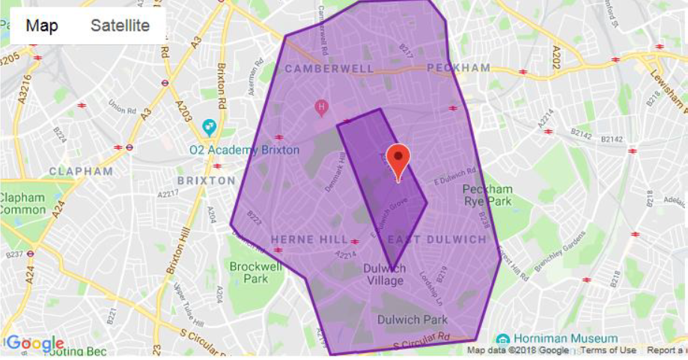

## Registering is Easy

## New patients can register in a number of ways:

* **Online –** Visit our website [www.tessajowellgpsurgery.co.uk](http://www.tessajowellgpsurgery.co.uk) and follow instructions for online registration**. We would recommend online registration as this will allow you to make/cancel appointments, order prescriptions and contact the practice including when the surgery is closed.**
* **At the practice -** Pick up a registration form from the reception area and our staff can help you with any queries you may have.

In order to register at the practice please bring with you proof of your address (such as a utility bill or bank statement), photo ID (such as passport or driving license) and your NHS number (if you have one). If you do not have these documents please ask at reception for advice on how to register.

Once registered we will arrange for you to have a brief health check with a Practice Nurse or Health Care Assistant at a time convenient to you. This will give you an opportunity to discuss any health concerns and enables us to learn more about your health needs.

# Services

## Pre bookable Appointments

You can book an appointment with either a clinician for up to 4 weeks in advance. If you have a preferred clinician that you would like to see, please let us know when you book your appointment. Please note, patients may not always be able to see their preferred practitioner as they may not hold surgeries every day or they may be absent from the Practice (e.g. on annual or study leave).

## Same Day Appointments

We release same day appointments at 8am each day. You can telephone the surgery to book a same day appointment at 8am.Please be advised that we only have a limited amount of appointments for each sessions and they are allocated on a first come first served basis.

To make an appointment please contact our administrative team on **020 8194 7600.** Or use your online access to book into the same day slots

**Online patient access services**

As a registered patient of the Practice by registering for online services you are able to View, book and cancel appointments from home, work or on the move – wherever you can connect to the internet. Please ask for more information.

Patients who receive regular prescriptions from the practice can request a repeat prescription from the practice by logging onto the Patient-online Access system and selecting the drugs that are required. The Doctor will review the request and the patient is notified. You can also email in queries via eConsult- see the practice website homepage for more details at: [www.tessajowellgpsurgery.co.uk](http://www.tessajowellgpsurgery.co.uk)

#### Telephone Consultations

Many problems can be sorted out over the telephone without face-to-face contact with a doctor. Advice can be given and prescriptions issued. If you would like to speak to a doctor regarding a non-urgent issue, please request a telephone consultation.

**Home Visits**

To request a home visit please call us on **020 8194 7600** before 11am a clinician will call you before coming out to you to assess the request.

#### Cancelling Appointments

Please ensure that you cancel any appointment that you no longer require at least one hour before the appointment time this will enable us to offer this to another patient. Call us on:**020 8194 7600** or use the cancellation on the text reminder.

Please remember if you do not attend your appointment and have not notified us that you are not attending you are preventing another patient from using that appointment. Patients who repeatedly fail to attend appointments may be asked to register with another practice.

#### Disabled Access

At the Tessa Jowell GP Surgery, we are based on the first floor. There are lift facilities and hearing induction loops at this site.

#### Repeat Prescriptions

Please use your online access to order your repeat medications.

The Electronic Prescribing System ensures your prescription goes electronically to your nominated pharmacy please inform the reception team which pharmacy you would like to nominate. Alternatively you can nominate via the pharmacy.

Please ensure you allow two full working days for us to prepare your prescription. You may be required to attend a medication review before your repeat can be issued.

To avoid any errors we do not take any repeat prescription requests via the telephone.

#### Repeat Dispensing Scheme

If you are on regular medication your doctor can issue several prescriptions in advance to be held and distributed when you need them by your chosen pharmacy. This saves the patient time and inconvenience when ordering and collecting prescriptions.

#### Statements of Fitness for Work

Sickness Certificates for periods of less than 7 days should be signed by the patient themselves, in the form of a self-certification Form (SC2), available from your employer, GP or online at <https://www.gov.uk>

We will issue, free of charge, a Statement of Fitness for Work (sick certificate) to registered patients for whom we provide clinical care. A statement will not be issued to a patient until they have been off work for more than 7 calendar days. DSS certificates of incapacity are free and GP discretion see Non NHS Services.

#### Travel Medicine

We provide an advice and immunisation service to meet your travel needs. Please check your requirements with us as soon as you make your travel plans as some medicines require several courses. Travel advice is available from [www.fitfortravel.nhs.uk](http://www.fitfortravel.nhs.uk). Please note that not all travel vaccinations are available free on the NHS, there may be a charge for any immunisations you require to travel.

#### Test Results

Please note that the receptionist can only give results to patients once the Doctor has checked the results and given authorisation. In order to maintain patient confidentiality, results can only be given to the patient themselves.

Parents of patients under 16 can request results on the child’s behalf.

Most blood, urine and swab tests take up to two weeks to be processed and completed by the laboratory, these are then sent back to the surgery for review by your clinicians.

Patients are kindly asked to contact the surgery, after 2pm, two weeks after taking the test. The administrator will read back to you any comments that the clinicians have made and assist you with any follow up appointments, if required. If you have previously arranged a follow up appointment with your clinician you do not need to ring for the results.

#### Specialist and Hospital care

If a GP or another member of our healthcare team believes you need hospital treatment or specialist care elsewhere, this can be organised on your behalf. If you prefer to consider where and when you would like to arrange your appointment, you can be given a reference number and will be able to book the appointment yourself.

#### Non NHS Services & Private Fees

Certain services provided by your doctor are not covered by the NHS and you may be asked to pay a fee. These include:

* A Pre-employment Medical
* A Private Medical
* An Insurance Claim
* A Fitness To Drive Medical
* Travel immunisations
* Certain occupational vaccinations

Please call **0208 8194 7600** for more information or speak to a member of our administration team.

# Medical Records & Confidentiality

All patient records are confidential. All our staff are trained in accordance with the Data Protection Act and work under strict rules of confidentiality.

## Freedom of Information Act (2000)

From 1 January 2005, you can ask any public authority for information they hold. Public authorities will provide you with the information unless there is a good reason for not doing so.

## How We Use Your Records

The people who care for you use your records to:

* Provide a good basis for all health decisions made by you and care professionals
* Allow you to work with those providing care
* Make sure your care is safe and effective, and
* Work effectively with others providing you with care

**Others may also need to use records about you to:**

* check the quality of care (such as clinical audit)
* protect the health of the general public
* keep track of NHS spending
* manage the health service
* help investigate any concerns or complaints you or your family have about your health care
* teach health workers and
* help with research

Some information will be held centrally to be used for statistical purposes. In these instances we take strict measures to ensure that individual patients cannot be identified. We use anonymous information, wherever possible, but on occasions we may use personally identifiable information for essential NHS purposes such as research and auditing. However, this information will only be used with **your consent,** unless the law requires us to pass on the information. More information about how your information is used can be found on the practice website under the link to **privacy notices**.

## Changes to Personal Details

Please notify the surgery of any changes in your personal details such as your name, address or telephone number. This will enable us to keep our records up to date. This is very important as we may need to contact you at short notice.

# Patient Rights and Responsibilities

You have a right to expect a high standard of medical care from our practice and we will try at all times to provide the very best care possible within the resources available.

In order to assist us in this, we require that you take full responsibility for ensuring that you do not abuse the service. It is your responsibility to ensure that you keep appointments, on time, and follow the medical advice given. Please restrict your appointment to a maximum of one medical issue per appointment. If you have more issues you will need additional appointments.

The Tessa Jowell GP Surgery operates a zero tolerance policy. We will not tolerate any violent behaviour or abuse towards any member of our team. Any such behaviour will result in removal from our list.

## Patient Participation Group

This group is run by a committee of patients for the benefit of the Practice and Patients. **This is your group** so please ask how you can contribute your ideas. Further information can be found on the practice website at:

[www.tessajowellgpsurgery.co.uk](http://www.tessajowellgpsurgery.co.uk)

## Complaints

Should you wish to make a complaint about our service in the first instance, please ask to speak to a manager/supervisor.

Alternatively, you can put your complaint in writing to the Practice Manager. If the Practice cannot resolve the issue or should you be dissatisfied with the outcome you also have the right to approach the following:

**Independent Complaints Advocacy Service**: 0300 456 2370

Web: [www.pohwer.net](http://www.pohwer.net)

**The Parliamentary Ombudsman**: 0345 015 4033

Web: [www.ombudsman.org.uk](http://www.ombudsman.org.uk)

**NHS England**: 0300 311 22 33

Email: [England.contactus@nhs.net](mailto:England.contactus@nhs.net)

This medical practice is operated by Omnes Healthcare Ltd. **www.omneshealthcare.co.uk**

Registered in England and Wales No. 07751362

Registered address: Alexandra House, 43 Alexandra Street, Nottingham, NG5 1AY

*Printed September 2016*

*Information contained in this leaflet was correct at the time of printing*